**Introduction to high voltage**

High voltage (HV) refers to electrical potential difference significantly higher than the standard household voltage level. In most contexts, it's typically defined as voltage levels above 1,000 volts for AC and 1500 Volts for DC.

**Different Forms of High Voltage:**

1. **AC (Alternating Current) High Voltage**: Alternating current periodically changes direction, commonly used in power transmission systems.
2. **DC (Direct Current) High Voltage**: Direct current flows in one direction only, often used in specialized applications like electrostatic generators and high-voltage power supplies.
3. **Pulsed High Voltage**: Voltage that is delivered in short, intense pulses, used in applications like pulsed power systems and certain types of medical equipment.
4. **Impulse High Voltage**: Short duration voltage surges, often associated with lightning strikes or certain industrial processes.
5. **Radio Frequency (RF) High Voltage**: High voltage in the radio frequency range, utilized in radio transmission, particle accelerators, and RF heating systems.

**Benefits of Using High Voltage:**

1. **Efficiency**: High voltage reduces the current required for transmitting power over long distances, minimizing energy losses due to resistance.
2. **Compactness**: High voltage allows for the use of smaller conductors and transformers, leading to more compact power transmission infrastructure.
3. **Cost-Effectiveness**: By reducing energy losses and infrastructure requirements, high voltage transmission systems can be more cost-effective over long distances.
4. **Increased Power Capacity**: High voltage systems can transmit larger amounts of power compared to lower voltage systems, making them suitable for large-scale power distribution.
5. **Improved Performance**: Certain applications, like electric propulsion systems and industrial processes, benefit from the use of high voltage due to improved performance and efficiency.

**Voltage Level Classification:**

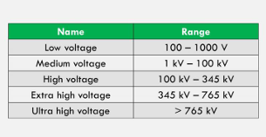

**Distribution and Transmission System in Nepal–**

Distribution Voltages: -

3.3 KV /6.6KV/11KV/22KV/33KV – Variation 5%

Transmission Voltage: -

33KV/ 66KV/ 132KV/ 220KV/ 400KV –

Variation 10%

Frequency: -50 Hz,

Power Factor: - Distribution-0.8,

Generation: -0.85-1

**Fields of Application of High Voltage (HV):**

1. **Power Transmission**: High voltage is essential for transmitting electrical power over long distances efficiently.
2. **Industrial Processes**: High voltage is used in various industrial processes such as arc welding, electrostatic precipitation, and materials processing.
3. **Medical Equipment**: Certain medical devices, like X-ray machines and particle accelerators, require high voltage for operation.
4. **Research and Development**: High voltage is indispensable in scientific research, particularly in fields like plasma physics, particle physics, and high-energy physics.
5. **Electric Propulsion**: High voltage systems are employed in electric propulsion technologies, including electric vehicles and spacecraft propulsion systems.

**Generation of High DC Voltages**

Generating high DC voltages finds wide applications across industries, research, and medical fields. One increasingly popular use is in HVDC transmission, both above ground and underground, for its efficiency. HVDC is also handy for testing lengthy HVAC cables, which have high capacitance and would otherwise demand immense currents for testing under HVAC voltages. In industry, HVDC comes into play for tasks like electrostatic ash precipitation in thermal plants, electrostatic painting, and in sectors like cement and communications. The simplest and most effective method for creating high DC voltages is rectification using voltage multiplier circuits. Additionally, electrostatic generators have been utilized for this purpose as well.

**Half wave rectifier circuit:**

The simplest circuit for generation of high direct voltage is the half wave rectifier shown in Fig. Here RL is the load resistance and C the capacitance to smoothen the D.C. output voltage.

If the capacitor is not connected, pulsating d.c. voltage is obtained at the output terminals whereas with the capacitance C, the pulsation at the output terminal is reduced. Assuming the ideal transformer and small internal resistance of the diode during conduction the capacitor C is charged to the maximum voltage Vmax during conduction of the diode D.

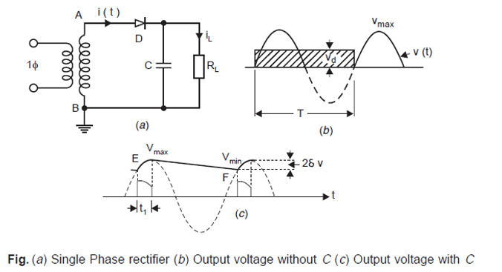

**Full wave rectifier:**

A bridge rectifier is an arrangement of four diodes in a bridge circuit configuration which provides the same output polarity for either input polarity. It is used for converting an alternating current (AC) input into a direct current (DC) output. For, the positive half cycle, D1 and D2 remain forward biased, while D3 and D4 are reversed biased. So, current flows the path (Source - D1 - Load - D2- Source) and positive polarity appears across the load. In the negative cycle, D3 and D4 remain forward biased while other two remains forward. And current flows the path (Source - D3 - Load - D4 - Source) and positive polarity appears across the load even the input is of negative polarity. And the output waveforms of it is shown below.

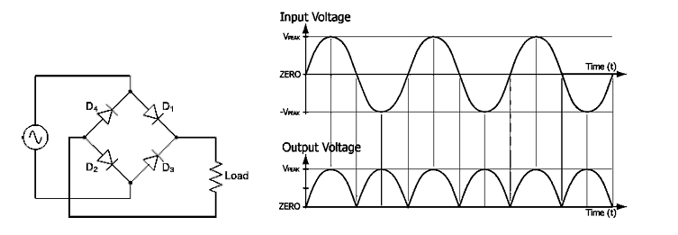

**Greinarcher voltage doubler circuits:**

DC high voltage is usually generated by voltage doubler circuit as shown in figure. During negative half cycle of AC voltage, D1 conducts there by charging the capacitor C1 to Vm with polarity. During next positive half cycle terminal A of the capacitor C1 rises to Vm and hence terminal ‘M’ attains a potential of 2Vm. Thus, the capacitor C2 is charged to 2Vm through D2.

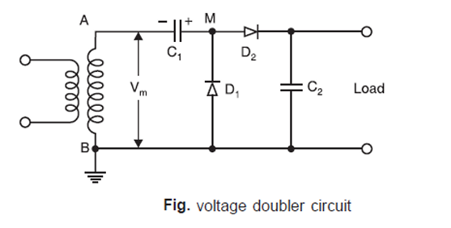

* The Greinacher voltage doubler circuit operates on the principle of charging capacitors in series and then connecting them in parallel to effectively double the voltage.
* The circuit typically consists of two stages, each comprising a capacitor and a diode connected in series.
* The first stage charges the capacitor to the input voltage during the positive half-cycle of the input voltage, while the diode prevents discharge during the negative half-cycle.
* During the negative half-cycle, the second stage capacitor charges through the diode to approximately twice the input voltage, effectively doubling it.
* At the output of the circuit, the voltage across the second capacitor is approximately twice the input voltage, assuming ideal diodes and capacitors.
* One drawback of the Greinacher voltage doubler circuit is that it can exhibit significant voltage ripple due to the charging and discharging of capacitors.
* The ripple can be minimized by using larger capacitance values or adding a smoothing capacitor across the output.

**COCKROFT-WALTON VOLTAGE MULTIPLIER CIRCUIT**

* The Cockcroft-Walton circuit, also known as a voltage multiplier circuit, is a type of cascaded voltage multiplier used to generate high DC voltages from low AC or DC inputs. It was originally developed by John Cockcroft and Ernest Walton in the 1930s for particle acceleration in early particle accelerators. Here's how it works:
* The Cockcroft-Walton circuit employs a ladder-like configuration of capacitors and diodes to produce an output voltage that is a multiple of the input voltage.
* The circuit consists of multiple stages, each comprising a capacitor and a diode arranged in a ladder-like structure.
* During each half-cycle of the input voltage, the capacitors in the ladder charge up to the peak value of the input voltage through the diodes.
* When the input voltage rises, the diodes conduct, allowing the capacitors to charge in parallel.
* During the negative half-cycle of the input voltage, the capacitors discharge through the diodes in series.
* Due to the series connection of capacitors during charging and the parallel connection during discharging, the voltage across each capacitor increases with each stage.
* As a result, the output voltage across the final capacitor is significantly higher than the peak input voltage.
* The output voltage of the Cockcroft-Walton circuit can be several times the peak value of the input voltage, depending on the number of stages in the multiplier.

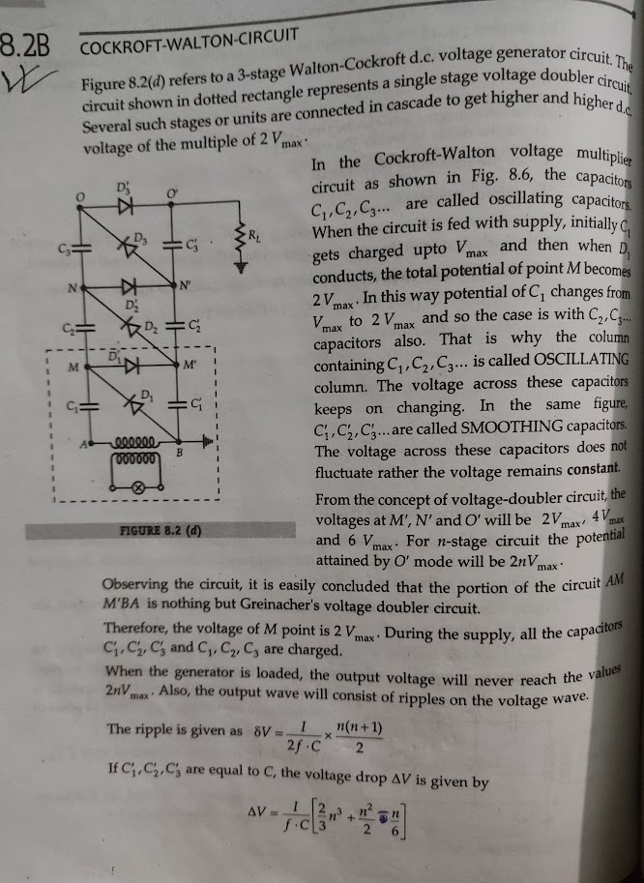

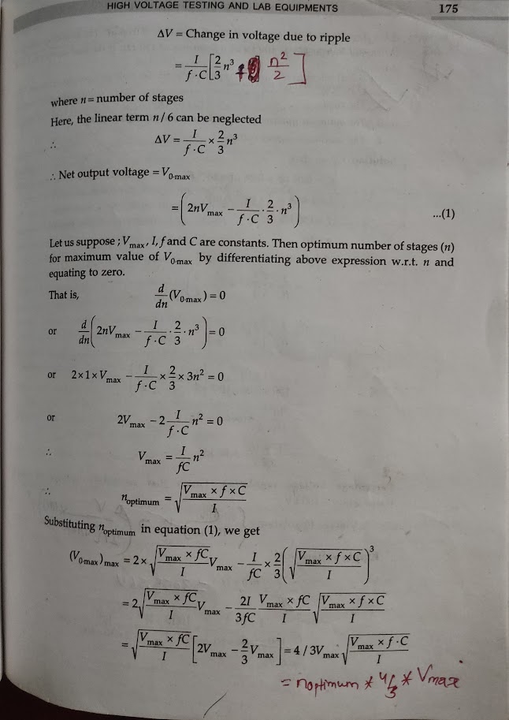

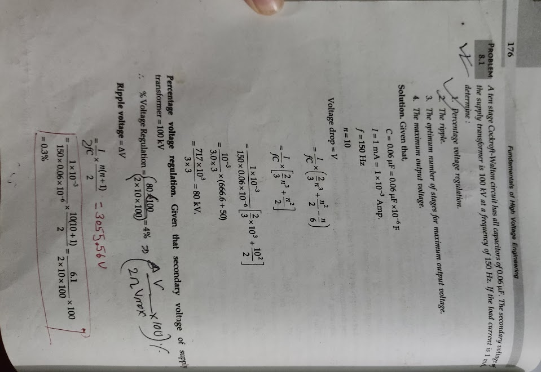

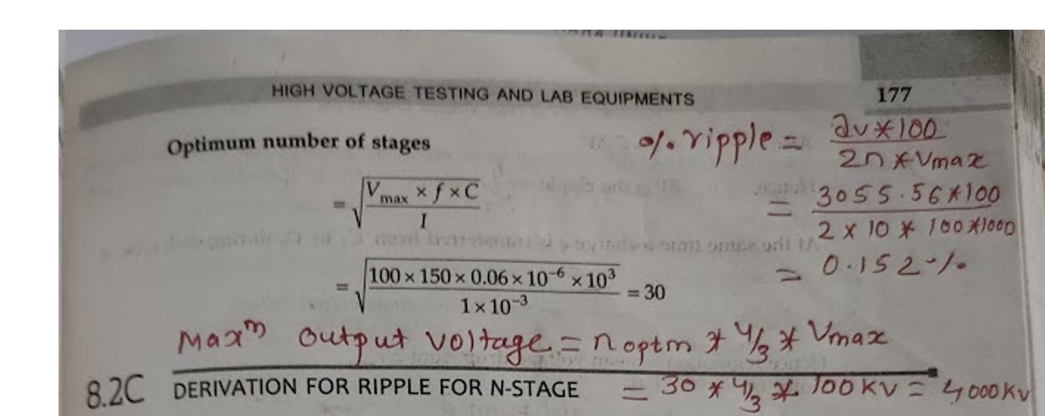

**1.2 Generation of High Ac Voltages**

High AC (Alternating Current) voltages are essential for various applications across industries, research, and power systems. They are typically generated using specialized equipment and techniques tailored to the specific requirements of each application.

**Applications:**

Power Transmission: High AC voltages are essential for long-distance power transmission, where step-up transformers are used to increase voltage levels for efficient transmission.

Research and Experiments: High AC voltages are used in scientific experiments, particularly in fields like plasma physics, particle physics, and high-energy physics.

Industrial Processes: Industries utilize high AC voltages in processes such as induction heating, plasma cutting, and certain types of material processing.

Medical Equipment: Certain medical devices, including X-ray machines and particle accelerators, require high AC voltages for operation.

Communications: High AC voltages are used in certain communication systems, such as radio transmitters and high-frequency amplifiers.

**Cascade transformers:**

Cascade transformers, also known as cascade-connected transformers or multi-stage transformers, are a type of transformer configuration used to achieve very high voltage levels from standard voltage inputs. They consist of multiple individual transformer stages connected in series, with each stage stepping up the voltage progressively.

For voltages higher than 400 KV, it is desired to cascade two or more transformers depending upon the voltage requirements. Figure shows a basic scheme for cascading three transformers. The primary of the first stage transformer is connected to a low voltage supply. A voltage is available across the secondary of this transformer.

The tertiary winding (excitation winding) of first stage has the same number of turns as the primary winding and feeds the primary of the second stage transformer. The potential of the tertiary is fixed to the potential V of the secondary winding as shown in Figure. The secondary winding of the second stage transformer is connected in series with the secondary winding of the first stage transformer, so that a voltage of 2V is available between the ground and the terminal of secondary of the second stage transformer.

Similarly, the stage-III transformer is connected in series with the second stage transformer. With this the output voltage between ground and the third stage transformer, secondary is 3V. it is to be noted that the individual stages except the upper most must have three-winding transformers. The upper most, however, will be a two-winding transformer.

Figure shows metal tank construction of transformers and the secondary winding is not divided. Here the low voltage terminal of the secondary winding is connected to the tank. The tank of stage-I transformer is earthed.

The tanks of stage-II and stage-III transformers have potentials of V and 2V, respectively above earth and, therefore, these must be insulated from the earth with suitable solid insulation. Through h.t. bushings, the leads from the tertiary winding and the hv winding are brought out to be connected to the next stage transformer.

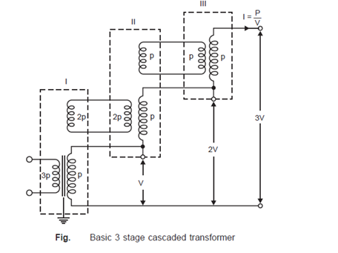

**Resonant transformer**

A resonant transformer, also known as a Tesla coil, is a type of high-frequency transformer that operates on the principle of resonance to generate extremely high voltages at high frequencies. It was invented by Nikola Tesla in the late 19th century and has since found numerous applications in science, industry, and entertainment. Here's an overview of resonant transformers:

* A resonant transformer utilizes the principle of electrical resonance, where the combination of inductance and capacitance in the circuit causes the system to oscillate at a specific frequency.
* The primary winding of the transformer is connected in series with a capacitor, forming an LC (inductance-capacitance) circuit.
* When an alternating current is applied to the primary winding, the LC circuit resonates at its natural frequency.
* As the primary winding oscillates at the resonant frequency, it induces a high-voltage alternating current in the secondary winding through electromagnetic induction.
* The secondary winding typically has many more turns than the primary winding, resulting in a significant step-up in voltage.

Resonant transformer is one of the best choices for high voltage generation which operates on resonance phenomenon (XL = Xc). If N is the transformation ratio and L is the inductance on the low voltage side of the transformer, then it is reflected with N2 L value on the secondary side (load side) of the transformer. For certain setting of the reactor, the inductive reactance may equal the capacitive reactance of the circuit, hence resonance will take place. Thus, the reactive power requirement of the supply becomes zero and it has to supply only the losses of the circuit.

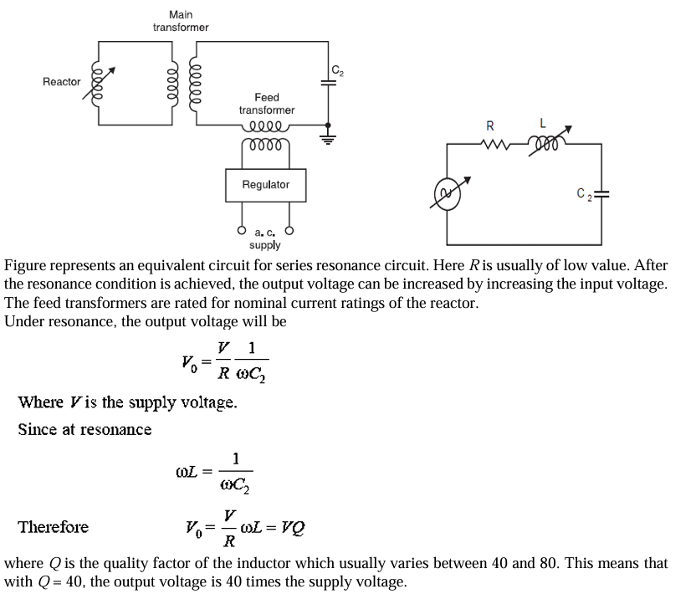

**Advantages: -**

The use of the Resonant transformer has the following advantages: -

* 1. Output will be in pure sine form.
  2. Power Requirements are less (5%- 10% of the total KVA.)
  3. No any high surges in case of the test object fail.
  4. Cascading is possible for the high voltage.
  5. Simple and compact test arrangements.

The main disadvantage is the requirements of the additional variable chokes for with standing voltage and current.

The series and the parallel resonant arrangements are shown as in fig.

• Primary is connected with the regulator (Auto transformer/induction regulator) and secondary of the transformer with reactor/inductor and capacitance.

• L is varied by varying air gap and C represents the test object.

• Quality factor = 50

• In case of the parallel circuit, reactor is connected as auto transformer and the circuit as parallel resonant circuit.

• The output voltage will be more stable w.r.t. to rise of voltage without dependency of Q-factor and tunning circuit.

• Single unit resonant test system can be built up to 500KV. For high voltage cascading can be done.

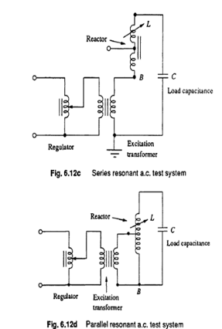

**High Frequency AC Voltage and Advantage of High Frequency Transformer:**

High frequency HV are required for the rectifier DC power Supply circuit.

• To Test Switching Surges, High frequency high voltage damped oscillation is needed which need HFHV transformer.

**ADVANTAGES of HFHV Transformers: -**

• Pure Sine wave output

• Less cost and reduced in sizes due to absence of the iron core.

• Slow built up of the voltage over a cycle and hence less chance of damage due to switching surges.

• Uniform distribution of the voltage across the winding.

**Van De-Graff Generator:**

* Fig. below shows the belt driven electrostatic generator–Van DeGraff, 1931.
* An insulating belt run over pulleys, driven with speed of about 15 to 30 m/sec, by means of a motor connected to the lower pulley.
* The belt near the lower pulley is charged electrostatically by an excitation arrangement. The lower charge spray unit consists of a number of needles connected to the controllable d.c. source (10 kV–100 kV) so that the discharge between the points and the belt is maintained.
* The charge is conveyed to the upper end where it is collected from the belt by discharging points connected to the inside of an insulated metal electrode through which the belt passes.
* The entire equipment enclosed in an earthed metal tank filled with insulating gases of good dielectric strength viz. SF6 etc. So that the potential of the electrode could be raised to relatively higher voltage without corona discharges or for a certain voltage a smaller size of the equipment will result.
* Shape of the h.t. electrode will be such that the surface gradient of electric field is made uniform to reduce again corona discharges.
* An isolated sphere is the most favorable electrode shape and will maintain a uniform field E with a voltage of Er where r is the radius of the sphere.
* As the h.t. electrode collects charges its potential rises. The potential at any instant is given as V = q/C where q is the charge collected at that instant. HV can be generated collecting charge for long time. With the rise potential of electrode that may ionize the surrounding medium, so this would be the limiting value of the voltage.

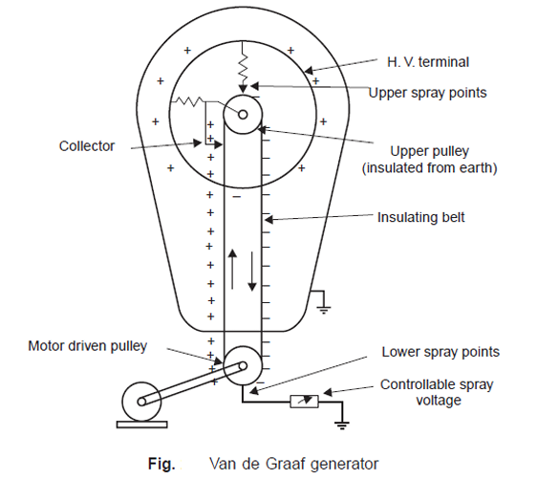

* The moving belt system also distorts the electric field so properly shaped field grading rings used.
* The collector needle system is placed near the point where the belt enters the h.t. terminal.
* As the pulley is at a higher potential (positive), the negative charges due to corona discharge at the upper spray points are collected by the belt. This neutralizes any remaining positive charge on the belt and leaves an excess of negative charges on the down going belt to be neutralized by the lower spray points. Since these negative charges leave the h.t. terminal, the potential of the h.t. terminal is raised by the corresponding amount.
* In order to have a rough estimate of the current supplied by the generator, let us assume that the electric field E is normal to the belt and is homogeneous. the current supplied by the generator is given as I = σ*b*ν
* From equation it is clear that current I depend upon σ, b and ν. The belt width (b) and velocity ν being limited by mechanical reasons, the current can be increased by having higher value of σ (charge density). σ can be increased by using gases of higher dielectric strength so that electric field intensity E could be increased without the inception of ionization of the medium surrounding the h.t. terminal. However, with all these arrangements, the actual short circuit currents are limited only to a few mA even for large generators.

**Advantages:**

**High Voltage Generation:** Van de Graaff generators can produce extremely high voltages, often reaching tens or even hundreds of thousands of volts. This makes them useful for experiments that require high electric potentials.

**Low Current Output:** While producing high voltages, Van de Graaff generators typically output very low currents. This characteristic makes them safer to handle compared to other high-voltage sources, as the risk of electric shock is minimized.

**Steady Voltage Output:** Van de Graaff generators can maintain a steady voltage output once they reach their operational state. This stability is beneficial for experiments and demonstrations that require a constant voltage source.

**Disadvantages:**

**Limited Current Capacity:** While Van de Graaff generators produce high voltages, they have limited current capacity due to their design. This limitation makes them unsuitable for applications requiring significant electrical power.

**Complexity and Maintenance**: Van de Graaff generators consist of components such as belts, pulleys, and brushes, which require regular maintenance and calibration to ensure proper functioning. Additionally, their construction can be relatively complex, requiring careful assembly and setup.

**Size and Cost:** Large Van de Graaff generators can be bulky and expensive to build and operate, especially those designed for research purposes. Smaller versions exist for educational demonstrations, but they may still require a significant investment.

**Applications:**

**Physics Education:** Van de Graaff generators are commonly used in physics classrooms and laboratories to demonstrate principles of electrostatics, such as charge accumulation, electric field formation, and discharge phenomena.

**Particle Acceleration:** They are utilized in particle accelerators to generate high voltages for accelerating charged particles, such as electrons or ions, to high energies. Van de Graaff generators serve as injectors or pre-accelerators in some particle accelerator setups.

**High-Voltage Experiments:** Researchers use Van de Graaff generators in various high-voltage experiments, including studies on dielectric breakdown, plasma physics, and high-energy physics phenomena.

**Medical and Industrial Applications:** Van de Graaff generators find applications in medical and industrial settings, such as radiation therapy and material surface treatment, where high voltages are required for specific processes.

**Generation of Impulse Voltages:**

An impulse voltage is a unidirectional voltage which, without appreciable oscillations, rises rapidly to a maximum value and falls more or less rapidly to zero. The maximum value is called the peak value of the impulse and the impulse voltage is specified by this value. Small oscillations are tolerated, provided that their amplitude is less than 5% of the peak value of the impulse voltage. In case of oscillations in the wave shape, a mean curve should be considered.

If an impulse voltage develops without causing flash over or puncture, it is called a full impulse voltage; if flash over or puncture occur, thus causing a sudden collapse of the impulse voltage, it is called a chopped impulse voltage. A full impulse voltage is characterized by its peak value and its two-time intervals, the wave front and wave tail time intervals defined below:

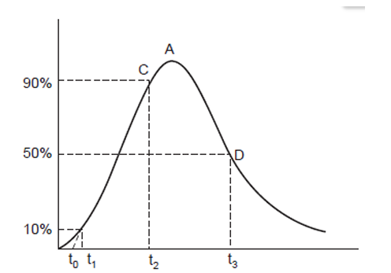

The wave front time of an impulse wave is the time taken by the wave to reach its maximum value starting from zero value. Usually, it is difficult to identify the start and peak points of the wave and, therefore, the wave front time is specified as 1.25 times (t2 – t1), where t2 is the time for the wave to reach to its 90% of the peak value and t1 is the time to reach 10% of the peak value. Since (t2 – t1) represents about 80% of the wave front time, it is multiplied by 1.25 to give total wave front time.

The nominal wave tail time is measured between the nominal starting point t0 and the point on the wave tail where the voltage is 50% of the peak value i.e. wave fail time is expressed as (t3 – t0). The nominal steepness of the wave front is the average rate of rise of voltage between the points on the wave front where the voltage is 10% and 90% of the peak value respectively.

The standard wave shape specified in BSS and ISS is a 1/50 micro sec. wave i.e. a wave front of 1 micro sec. and a wave tail of 50 micro sec. A tolerance of not more than ±50% on the duration of the wave front and 20% on the time to half value on the wave tail is allowed. The wave is completely specified as 100 kV, 1/50 micro sec. where 100 kV is the peak value of the wave.

The wave shape recommended by the American Standard Association is 1.5/40 micro sec. with permissible variations of 0.5 micro sec. on the wave front and ±10 micro sec. on the wave tail.

**Impulse Generator Circuits:**

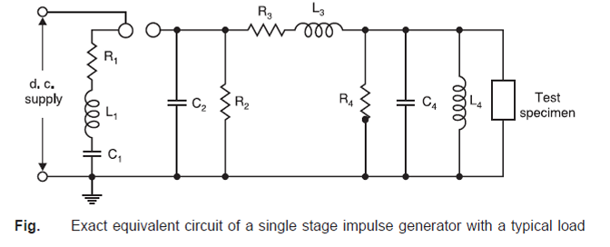

Figure above represents an exact equivalent circuit of a single stage impulse generator along with a typical load. C1 is the capacitance of the generator charged from a dc source to a suitable voltage which causes discharge through the sphere gap. The capacitance C1 may consist of a single capacitance, in which case the generator is known as a single stage generator or alternatively if C1 is the total capacitance of a group of capacitors charged in parallel and then discharged in series, it is then known as a multistage generator.

L1 is the inductance of the generator and the leads connecting the generator to the discharge circuit and is usually kept as small as possible. The resistance R1 consists of the inherent series resistance of the capacitances and leads and often includes additional lumped resistance inserted within the generator for damping purposes and for output waveform control. L3, R3 are the external elements which may be connected at the generator terminal for waveform control. R2 and R4 control the duration of the wave. However, R4 also serves as a potential divider when a CRO is used for measurement purposes. C2 and C4 represent the capacitances to earth of the high voltage components and leads. C4 also includes the capacitance of the test object and of any other load capacitance required for producing the required wave shape. L4 represents the inductance of the test object and may also affect the wave shape appreciably.

**Analysis of impulse generator circuit of series RLC type:**

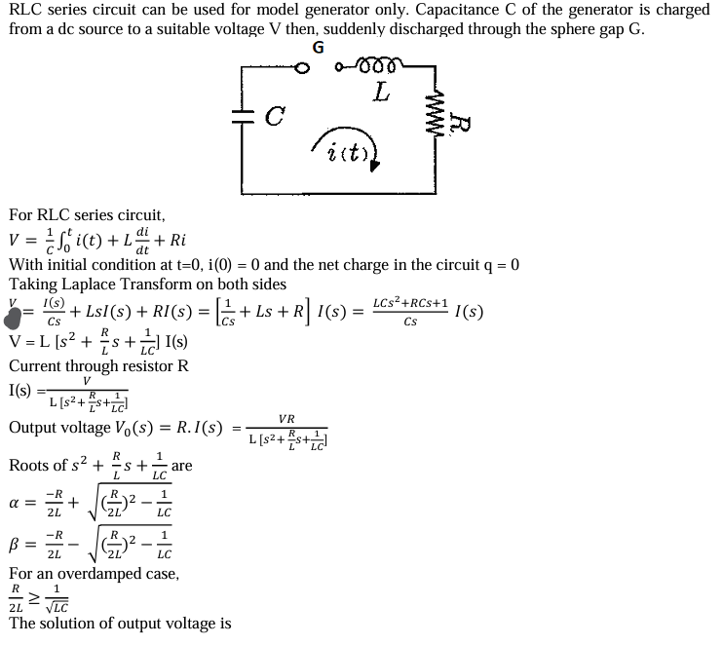

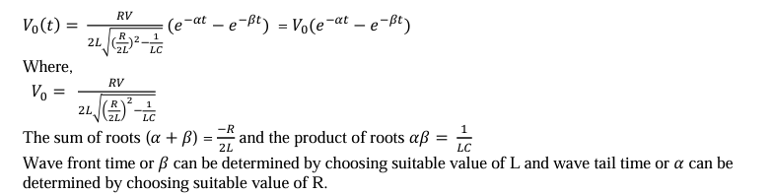

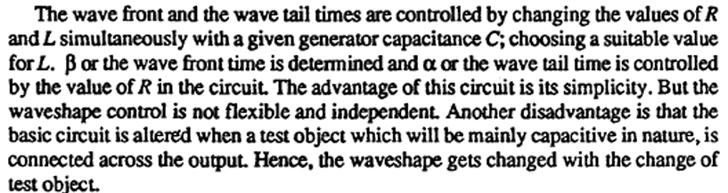

**Analysis of other impulse generator circuit:**

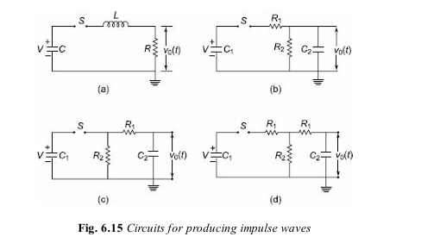

The most commonly used configurations for impulse generators are the circuits shown in Figs 6.15 b and c. The advantages of these circuits are that the wave front and wave tail times are independently controlled by changing either R1 or R2 separately. Secondly, the test objects which are mainly capacitive in nature from part of C2

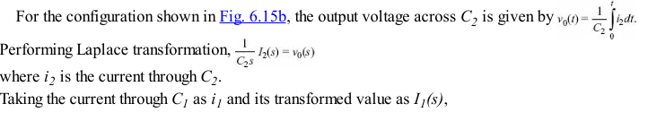

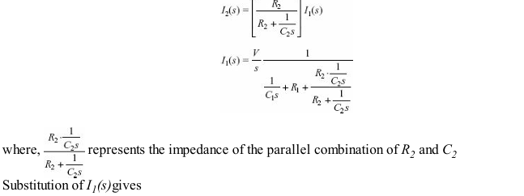

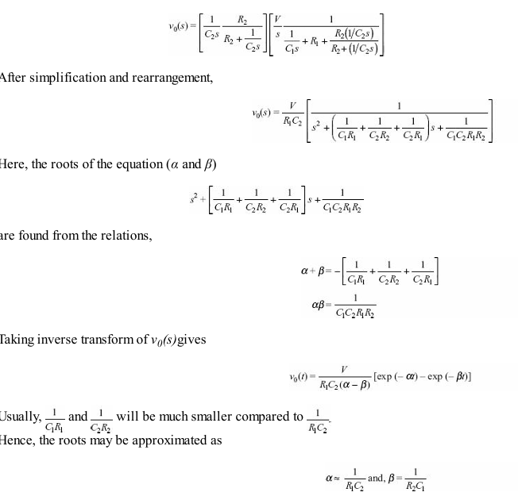

Generally, for a given impulse generator of Fig. 6.15b or c the generator capacitance C1 and load capacitance C2 will be fixed depending on the design of the generator and the test object. Hence, the desired waveshape is obtained by controlling R1 and R2. The following approximate analysis is used to calculate the wave-front and wave-tail times.

The resistance R2 will be large. Taking the circuit inductance to be negligible during charging, C1 charges the load capacitance C2 through R1. Then the time taken for charging is approximately three times the time constant of the circuit and is given by:

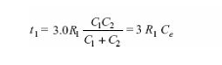

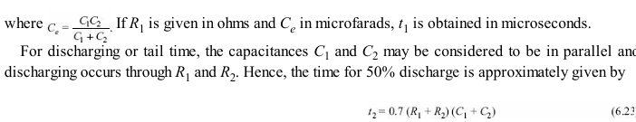

**Multistage impulse generator- Marx Circuit:**

